Renju lesson on October 18, 2001
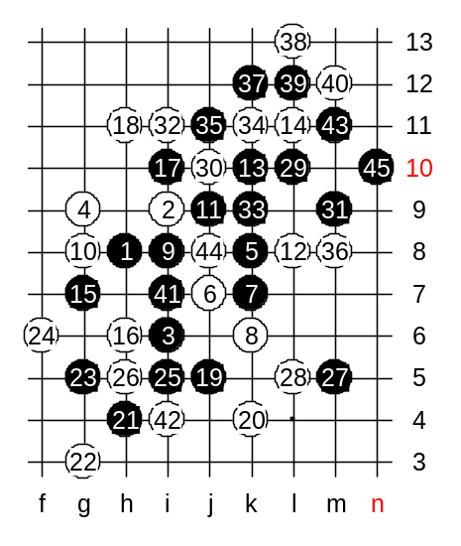
Hello everyone! Welcome to Online Renju Class. We will now begin. Today we will continue the study of i8 opening. We set the first 31 moves to be the same as the last week diagram. Please everybody tell me and assistant the moves, lets test your memory from last week lesson. Move 22-h4 connects the left and right side. For the start, let us check the variant of last week advanced homework. How many of you found the solution? I have a question. Can black win with similar way as in last week diagram, m6, m7? You all say NO. But why? What’s the difference? What happens if black still tries m6, m7 here? Yes, the point k9 will be 4x4 trap. Therefore, let us make the correct moves instead. There are 35 moves on board. If 36-L9 then same win as last week, right? So, 36-m8 is forced. Agree? And now what?
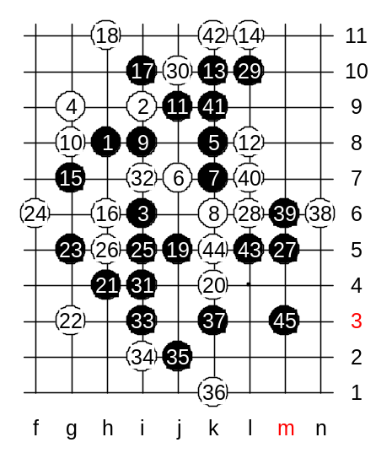

Now, let us try another 28th move. We have tried 28-L5 already. Now we will try another block. We try L6. We see, black plays L10. It is very important move.

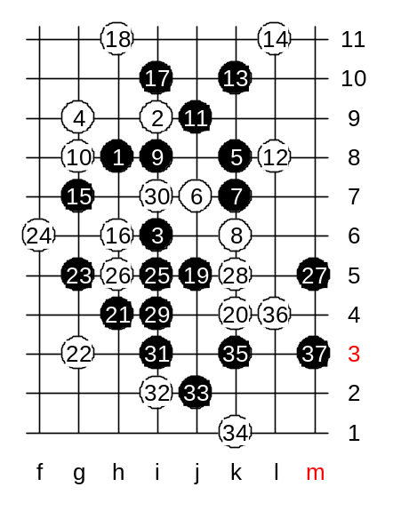

Another 28th move. 28-k5, as promised. Does anyone know the win here? Good, here it it.

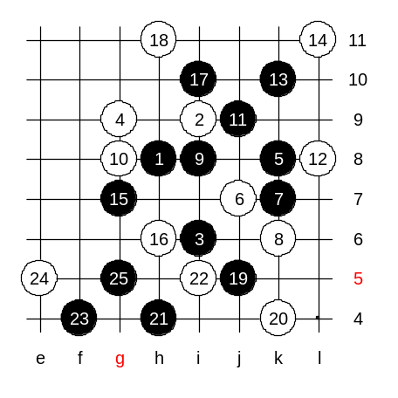
Another 22nd move. I5. Can you guess the next move from Fedorkin analysis? Powerful g5 ends the attack – white has no defense.

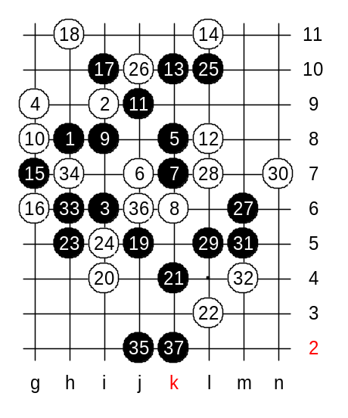
Another 16th move now. Let’s see how many of you remember the last week homework. Where is another 16th move here? Good, g6. As you notice, the 17 and 19 are same in this case. There are 24 moves on board. This is the typical development from this 16th move. Next, L10 must! Move h6 prepares the VCF threat.

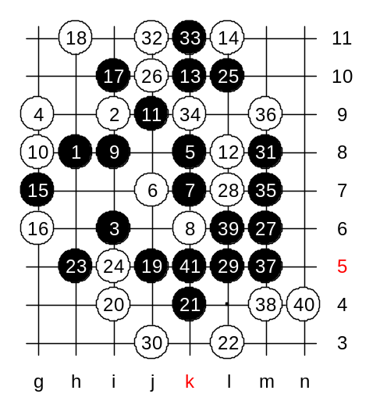

Now, while RH prepares the credits, we will check one more block, without comments.

We have completed the analysis of this 4th move. Next week, another 4th move. See you then! :)

